How to login into online classes @ Kool Kinder
- Visit http://www.kool-kinder.com/login/ and click on “Virtual Class Login” as shown below.
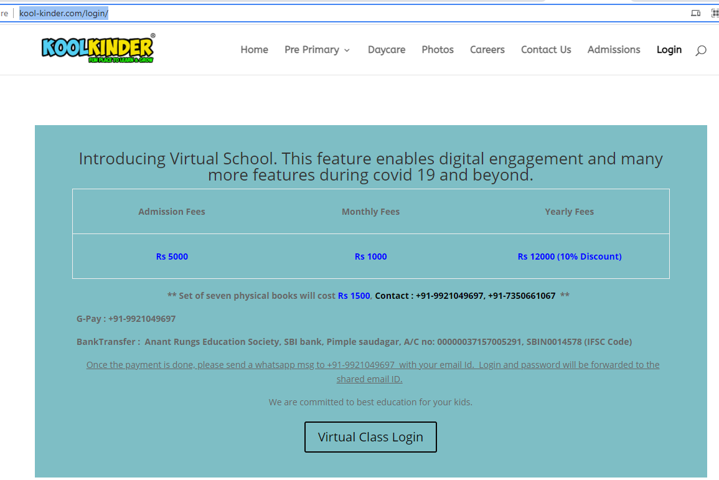
- Use the login Name and Password provided to SIGN IN the Virtual Class. Select your Role as Student or Staff.
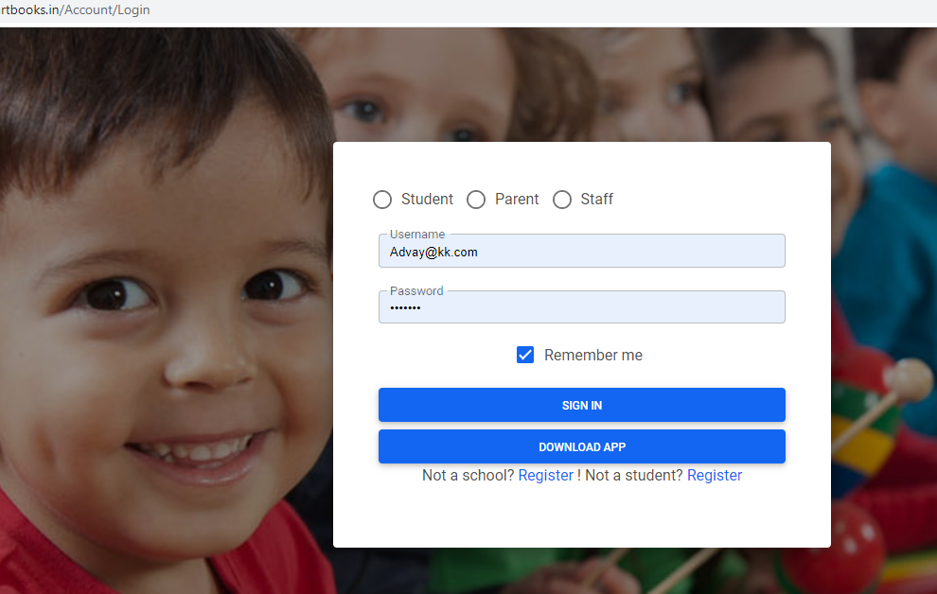

- You should see the main login screen as below.
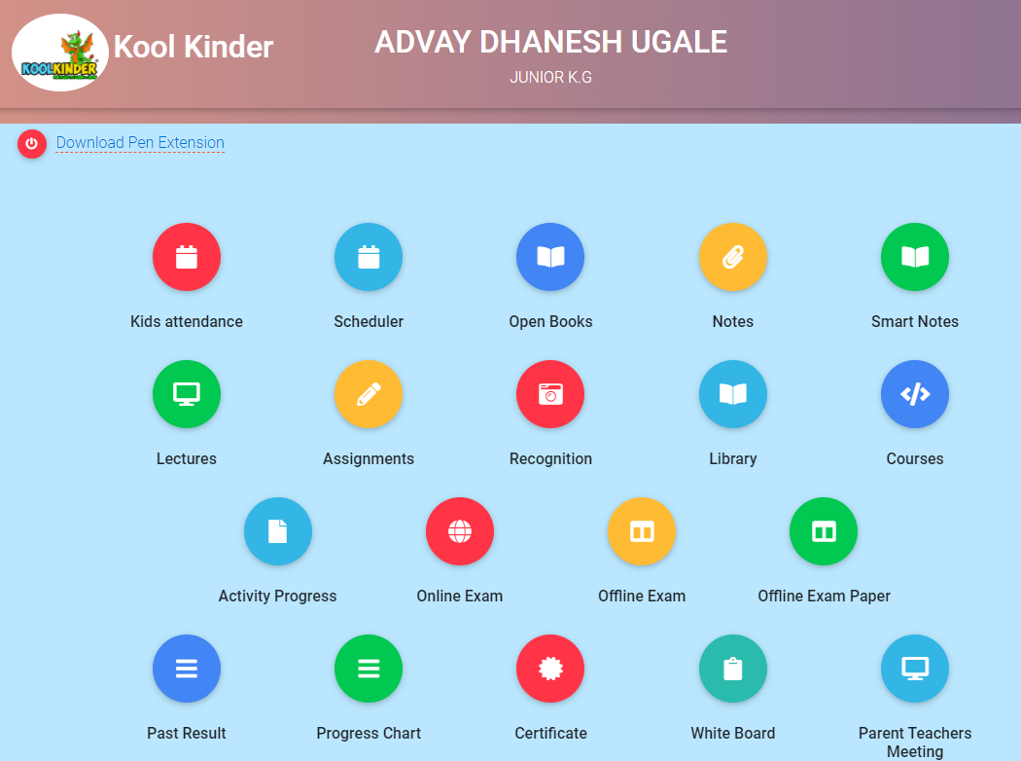
- Download Pen Extension: Click and download pen extension for chrome browser. It is recommended to have a Chrome browser with this extension.

